Lab 7

Ex 1:

|  |  |
| --- | --- |
| Function | Big O |
|  |  |
| void swap (int *a, int *b)  {  int temp=*a;  *a=*b;  *b=temp;  } | **O(1)[declaration and assignment]** |
| int partition(int array[], int low, int high)  {  int pivot= array[high];  int i=(low-1);    for(int j=low; j<=high-1; j++)  {  if(array[j]<pivot)  {  i++;  swap(&array[i],&array[j]);  }  }    swap(&array[i+1], &array[high]);  return (i+1);  } |  |
| void quicksort(int array[], int low, int high)  {  if (low<high)  {  int x= partition(array, low, high);  quicksort(array, low, x-1);  quicksort(array, x+1, high);  }  } | n  / \   1. n-1   / \   1. n-2   cn + c(n-1) + c(n-2)…..+2c  c()  **O(n2)** |
| void merge(int array[], int l, int m, int r)  {  int i, j, k;  int n1=m-l+1;  int n2=r-m;    int L[n1], R[n2];    for (i = 0; i < n1; i++)  L[i] = array[l + i];  for (j = 0; j < n2; j++)  R[j] = array[m + 1 + j];      i = 0;  j = 0;  k = l;  while (i < n1 && j < n2)  {  if (L[i] <= R[j])  {  array[k] = L[i];  i++;  }  else  {  array[k] = R[j];  j++;  }  k++;  }    while (i < n1)  {  array[k] = L[i];  i++;  k++;  }    while (j < n2)  {  array[k] = R[j];  j++;  k++;  }  } |  |
| void mergeSort(int array[], int l, int r)  {  if (l < r)  {  int m = l + (r - l) / 2;  mergeSort(array, l, m);  mergeSort(array, m + 1, r);    merge(array, l, m, r);  }  } | T(n) = $\left\{\begin{aligned}b if n=1 \\ T\left(\frac{n}{2}\right)+T\left(\frac{n}{2}\right)+cn\end{aligned}\right.$ T(n) =2(2T(n/2^2) + cn/2) + cn  T(n) =2^2T(n/2^2) + 2cn  T(n) =2^2T(n/2^2) + 2cn  T(n) =2^kT(n/2^k) + kcn  n/2^k = 1 => k=ln n  T(n) = nb + cn*ln n  **O(n)=n*ln n** |

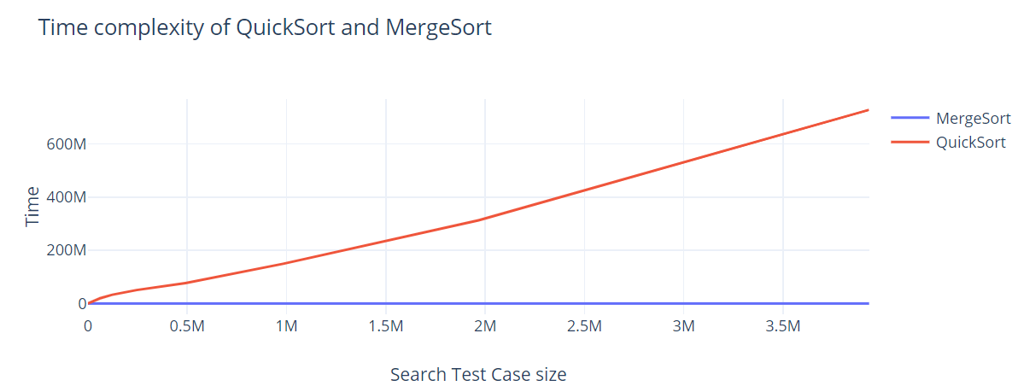

Ex 2:

|  |  |
| --- | --- |
| Function | Big O |
|  |  |
| void Split(Node* source,Node** frontRef, Node** backRef)  {  Node* fast;  Node* slow;  slow = source;  fast = source->next;  while (fast != NULL) {  fast = fast->next;  if (fast != NULL) {  slow = slow->next;  fast = fast->next;  }  }  *frontRef = source;  *backRef = slow->next;  slow->next = NULL;  } | While loop would continue for n-1 times where n is the number of elements in source node.  Hence O(n) |
| Node* SortedMerge(Node* a, Node* b)  {  Node* result = NULL;  if (a == NULL)  return (b);  else if (b == NULL)  return (a);  if (a->data <= b->data) {  result = a;  result->next = SortedMerge(a->next, b);  }  else {  result = b;  result->next = SortedMerge(a, b->next);  }  return (result);  } | O(n)[as n comparisons] |
| void MergeSort(Node** headRef)  {  Node* head = *headRef;  Node* a;  Node* b;  if ((head == NULL) || (head->next == NULL)) {  return;  }  Split(head, &a, &b);  MergeSort(&a);  MergeSort(&b);  *headRef = SortedMerge(a, b);  } | O(n)[discussed above]  O(n)  **O(n)** |
| void printList(Node* node)  {  while (node != NULL) {  cout << node->data << " ";  node = node->next;  }  } | O(n)[elements in node] |
| void push(Node** head_ref, int new_data)  {  Node* new_node = new Node();  new_node->data = new_data;  new_node->next = (*head_ref);  (*head_ref) = new_node;  } | O(1)[declaration, assignment] |

